Djordje Stevan Nesic’s career as a pianist has been highlighted by recital, concerto, chamber, and collaborative performances. During the current season, Mr. Nesic performs in both concert and recital at Weill Hall, Ravinia Festival’s “Rising Star Series,” and the Brooklyn Music Club. He is also featured in the PBS broadcast of “This Little Light of Mine” with soprano Adrienne Danrich. Among the pianist’s recent Manhattan performances are those at Lincoln Center in its “Meet the Artist” series; Carnegie’s Weill Hall with Samantha Jeffreys and Monica Yunus; the United Nations General Assembly Hall; the River to River Festival; Tribeca’s Ico Gallery; the Princeton Club; and the Riverside Church.

The 2009-2011 season included appearances at the Mann Performing Arts Center in Philadelphia; Carnegie’s Zankel Hall; and the “Sing for Hope Gala” presented at Lincoln Center.

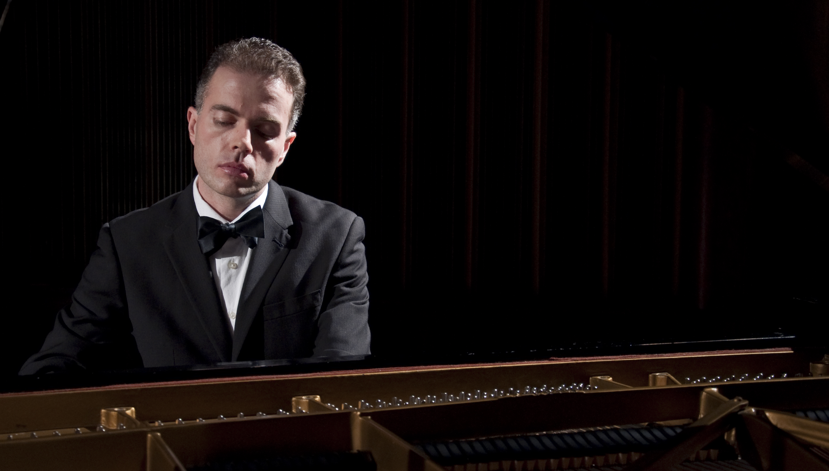
In his capacity as an accomplished vocal coach, Djordje Nesic spent the summer of 2010 preparing Dvořák’s Rusalka at the Bohemian National Hall (New York City) and coaching Henze’s El Cimarron at the Greenwich Music Festival (GMF) in Connecticut. During GMF’s 2009-2010 season, Mr. Nesic served as vocal coach and performed as pianist for Viktor Ullmann’s Der Kaiser von Atlantis. A film of the production premiered at the 2010 Westchester Jewish Film Festival. That same season, he prepared and performed the operas Dinner and Delusion by Michael Sahl and Nancy Manocherian and Clarence and Anita by Benjamin Yarmolinsky at the Cell Theater in New York in collaboration with the Center for Contemporary Opera.

In 2007, Mr. Nesic appeared with soprano Hanan Alattar at Carnegie’s Weill Hall in a recital sponsored by the Marilyn Horne Foundation. The previous year, he performed with soprano Monica Yunus at an honorary event for the vocalist’s father Professor Mohammad Yunus—winner of the 2006 Nobel Peace Prize. The pianist’s 2006 schedule included participation as a panelist for Opera America’s “Who’s in Charge of Rehearsal?”; Lieder workshops at Carnegie Hall with bass-baritone Daniel Gross; and a recital with famed German singer Thomas Quasthoff.

Mr. Nesic also coached Audra McDonald in preparation for her Houston Grand Opera debut in Michael John La Chiusa’s Send (Who are You? I Love You) and Poulenc’s The Human Voice

A Slavic-diction specialist, Djordje Nesic is in high demand as an opera coach, as well as a vocal-recital collaborator. Professional affiliations include those with The Juilliard School, the University of Texas at San Antonio, the Ash Lawn (Charlottesville, Va.) Opera Festival, and California State University, Long Beach. With the Glimmerglass Opera—both in New York City and in the Cooperstown area—Mr. Nesic has been featured in productions sponsored and organized by the company. Under the auspices of Glimmerglass, he has performed as a pianist and served as a panelist in live radio broadcasts from the state of New York’s NPR affiliates WAMC (Albany) and WXIX (Rochester). Television appearances have included live broadcasts from both the
“World Food Prize” ceremony and the city of New York for Japan’s FUJI station. A favorite of festival audiences, Mr. Nesic has performed at the Tanglewood, Cleveland Art Song, Lake Luzerne (NY) Chamber, and Aspen Music Festivals. The list of conductors with whom he has worked features Julius Rudel, James Conlon, Stewart Robertson, David Angus, Reinhardt DeLeeuw, Gerald Steichen, and Robert Spano.

Djordje Stevan Nesic, a roster member of the Swiss Global Artistic Foundation, currently lives in New York City where he holds the position of artist-in-residence at the Broadway Presbyterian Church.

